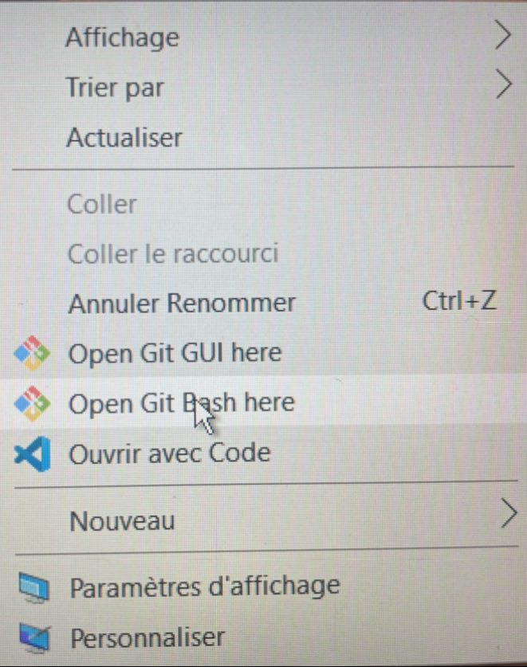
Ouverture Git

https://github.com/kevinyao2107/html-css-blog
git switch -c dev

Projet | index | commit |  |  |  | Push
Modirne local |  |  |  |  | Master/morin/GitHub /Internet /Server

